“The Dream” project

The project consists of mainly three parts: multi-ending game maker, AWS server and drawing board.

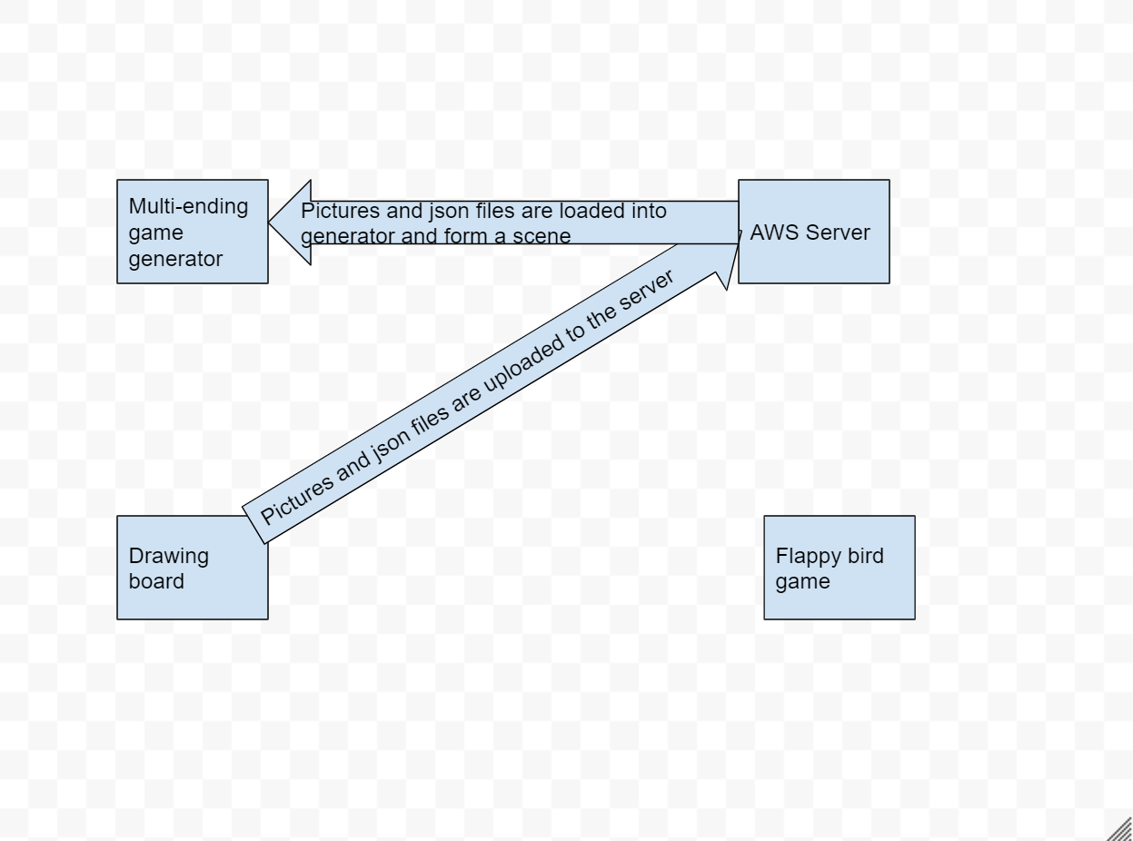

1. Player firstly start from consistent scene, click the third button to open drawing board.

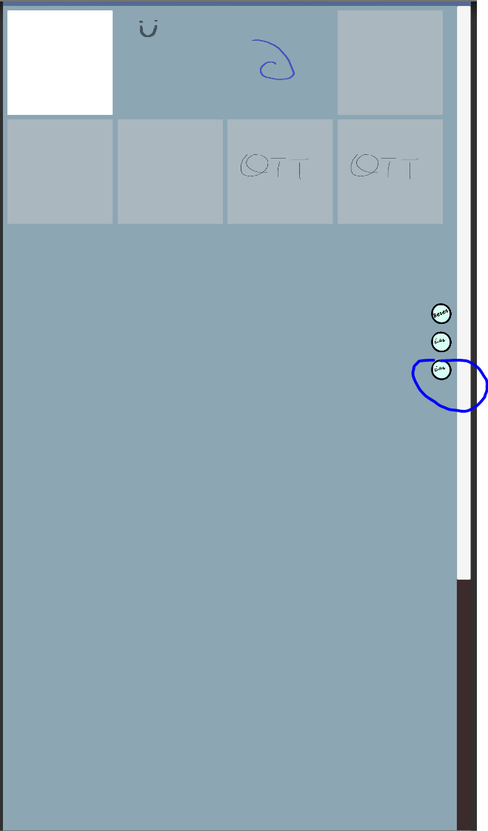

1. The drawing board has several functionalities such as: build layers, draw lines, withdraw lines, redraw lines, and add animations.

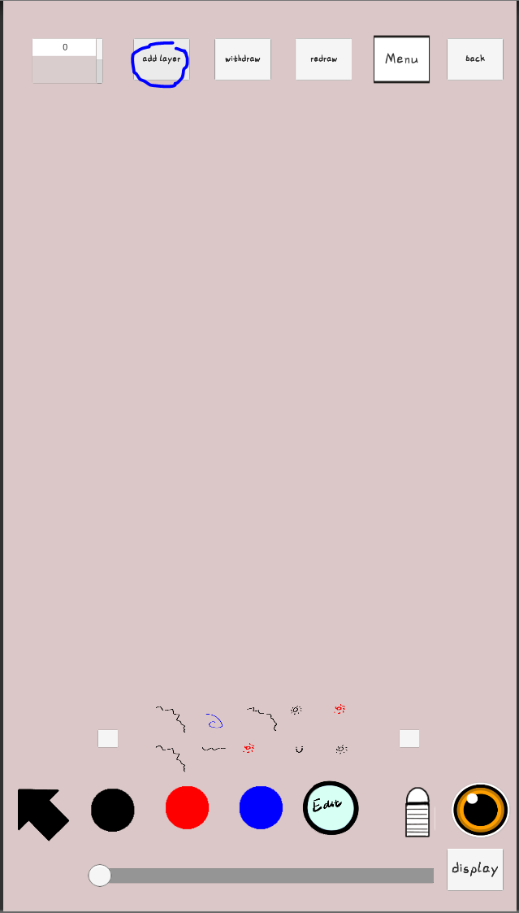

(click add layer button to add a new layer)

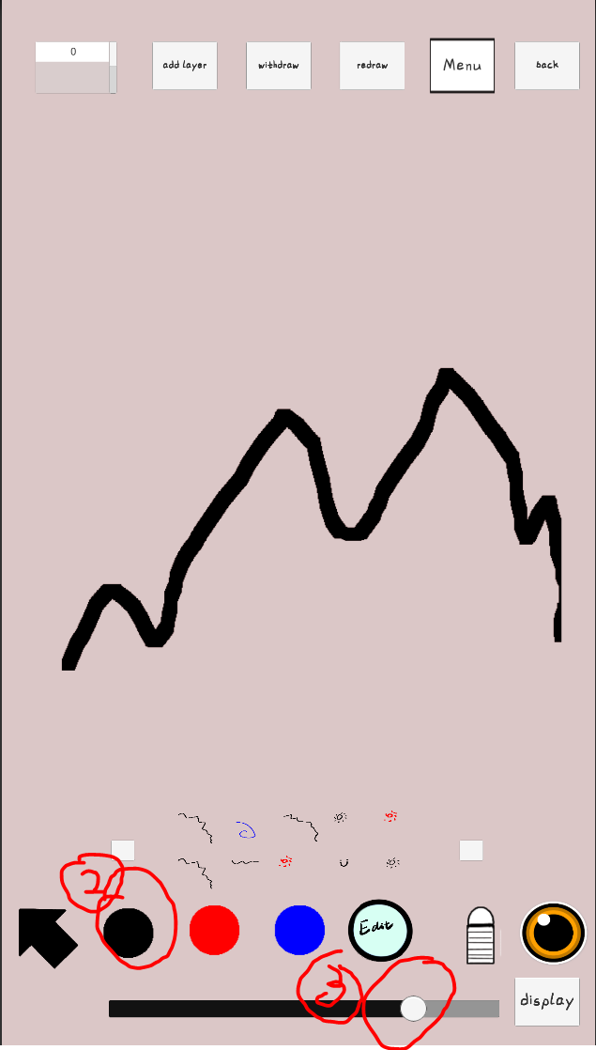

(pick a colour and pen width, draw something)

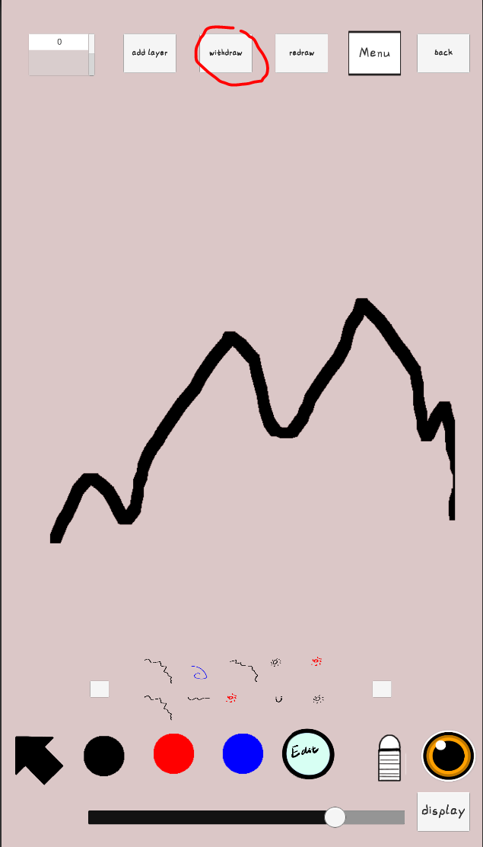

(click withdraw button to withdraw a line)

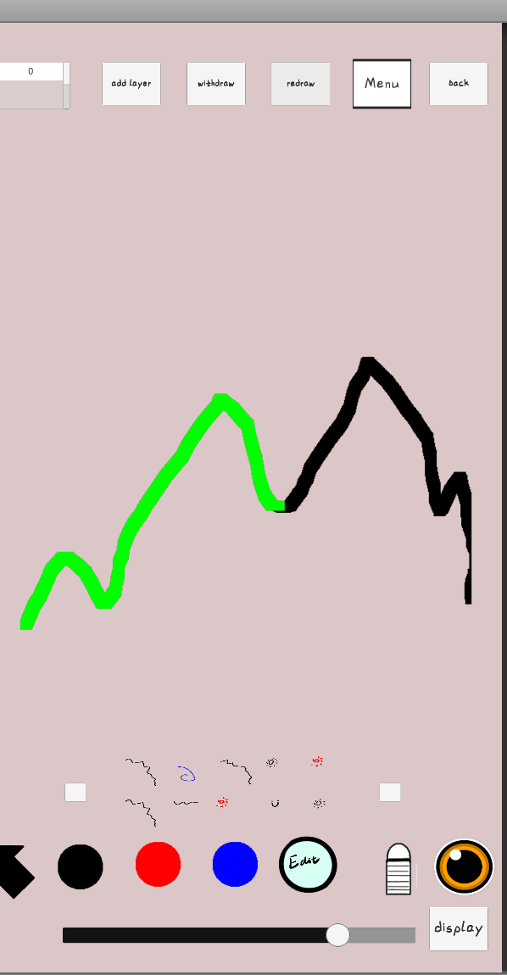



(click redraw button to redraw a line)

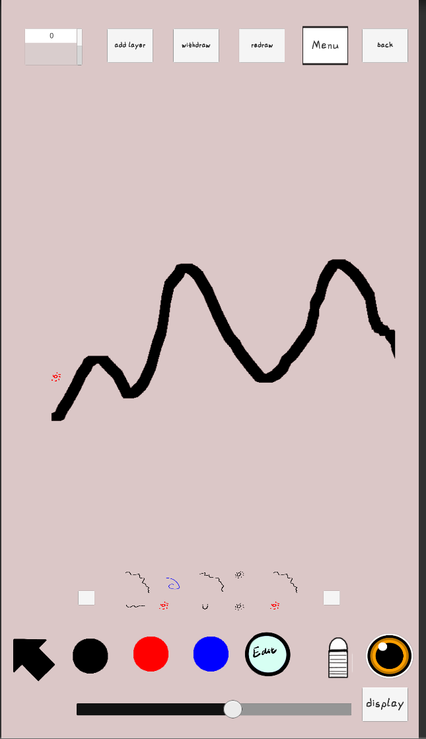



(click the black arrow first, then drag and drop little sprites from the inspection window)

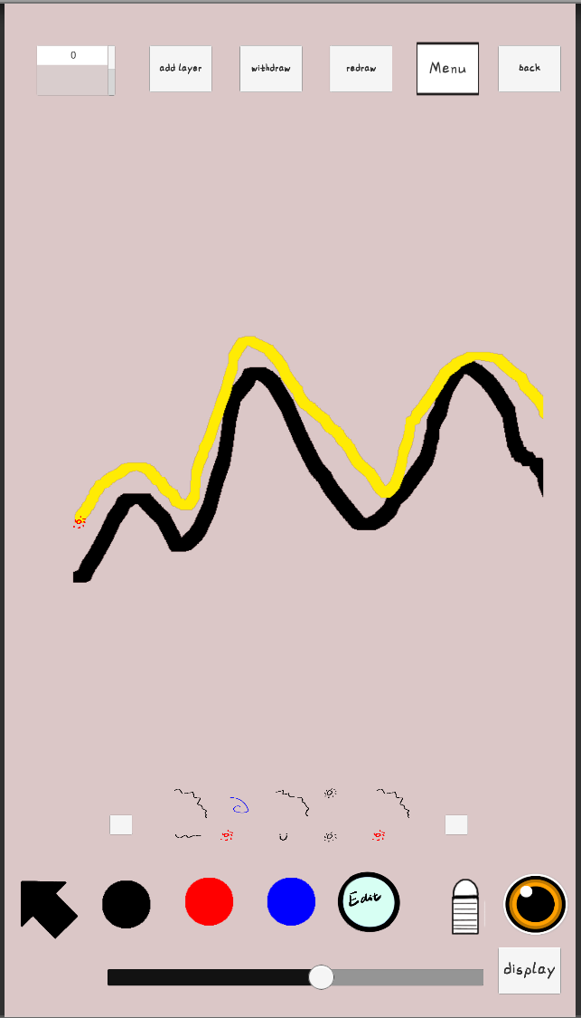



(click the edit button first, and then start from the sprite, draw a path that you wish the sprite to move)

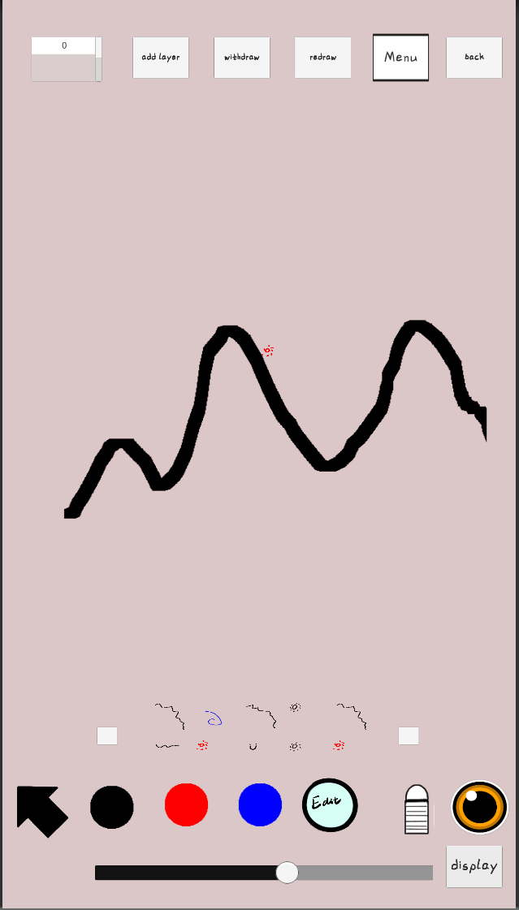



(click display to see the animation)

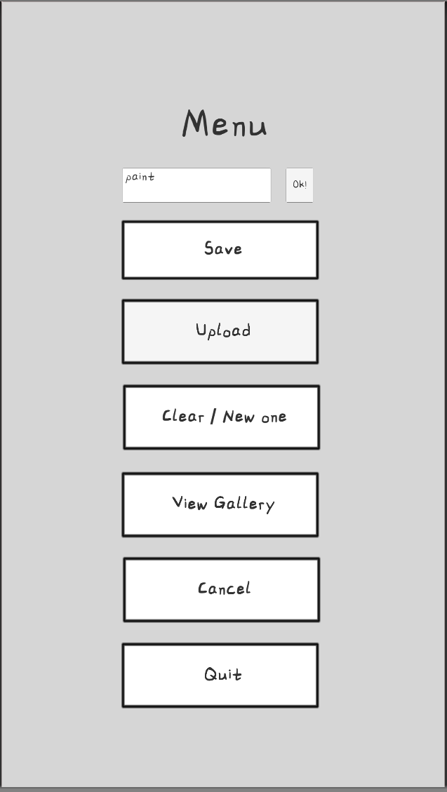



(click the menu button in the drawing board to open menu, name your painting, click ok button, then click upload button to upload it to server, then click cancel to go back to drawing board)

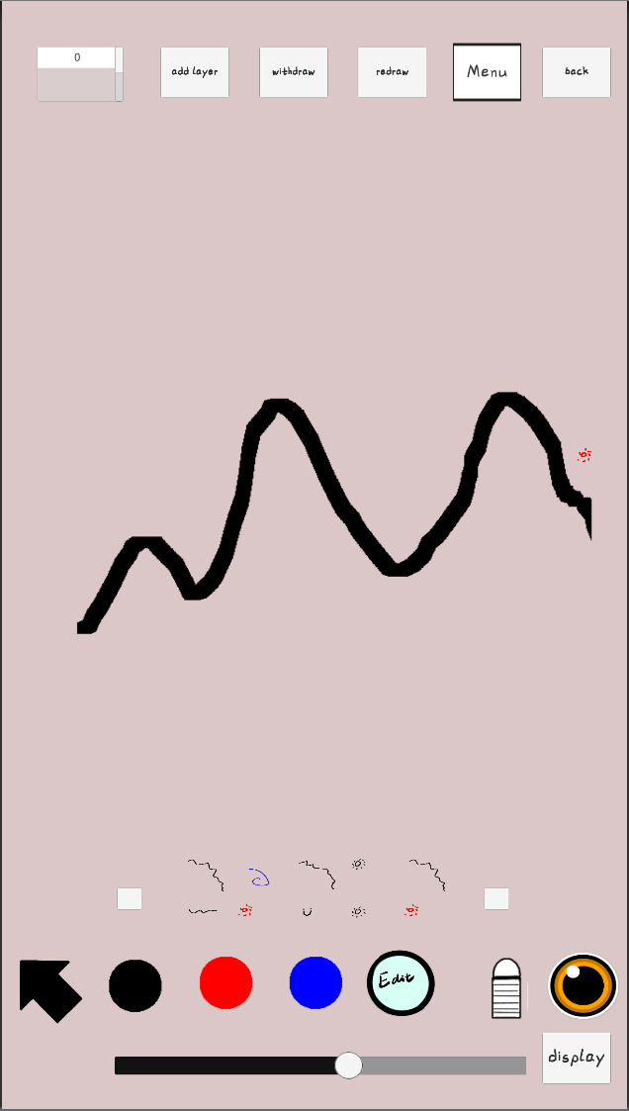



(click back button, let’s go to multi-ending game maker!!)

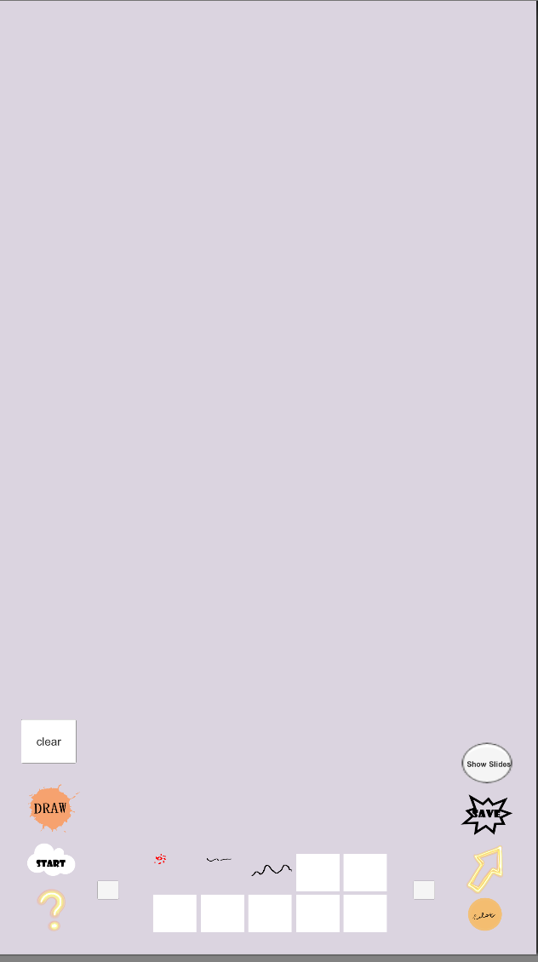



(this is the multi-ending game maker, first click edit button to open inspection window)

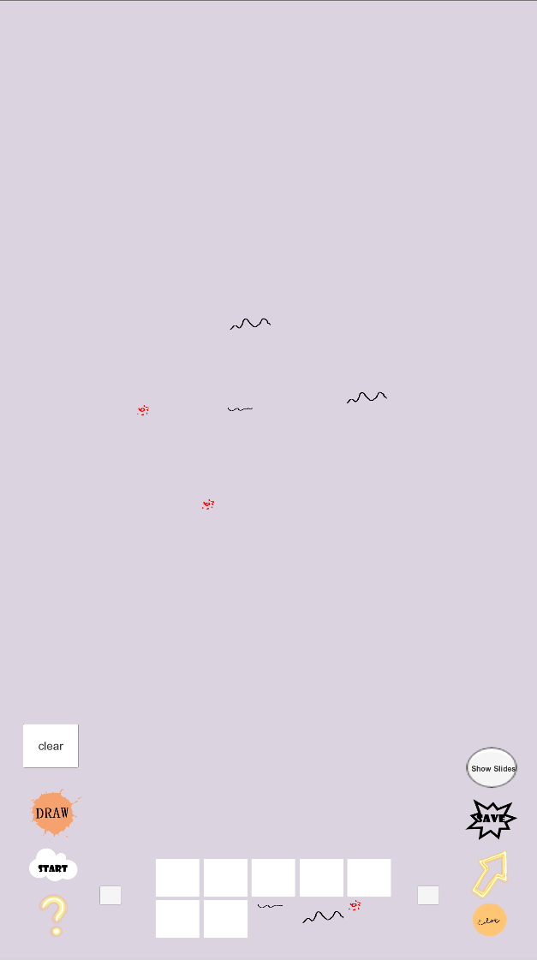

(then drag and drop the art you’ve created in drawingboard)

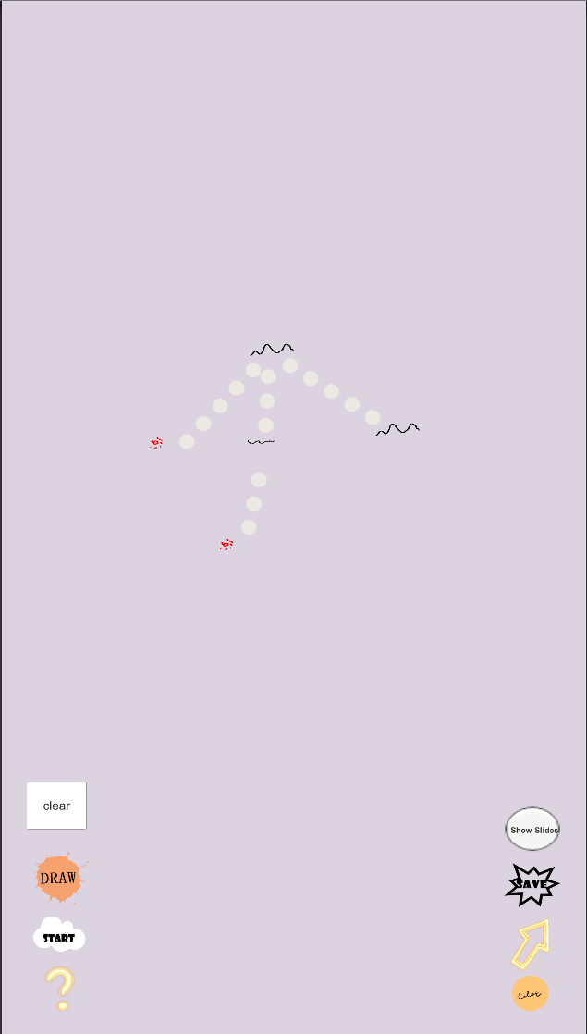



(click arrow button to go to arrow mode. Click one scene first and another to link them together)

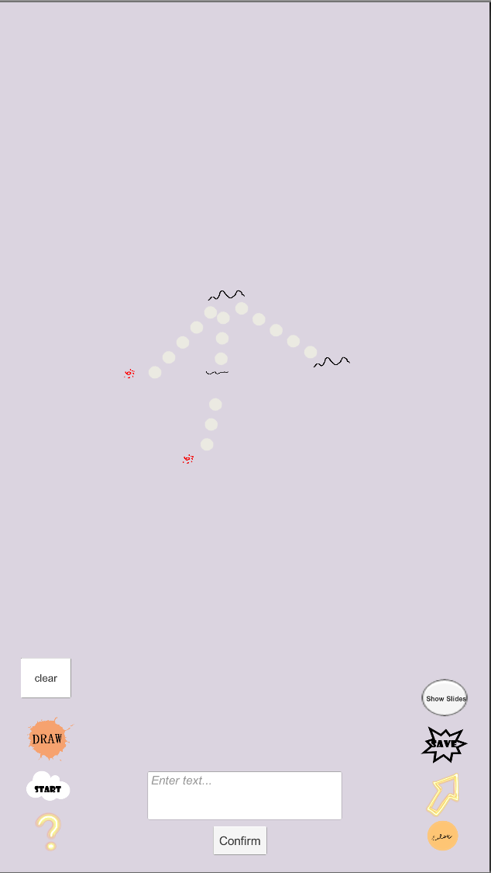



(click question mark button to go to edit description mode, in this mode, if you click scenes it’ll add description to scenes. If you click lines then it’ll add descriptions to choices)

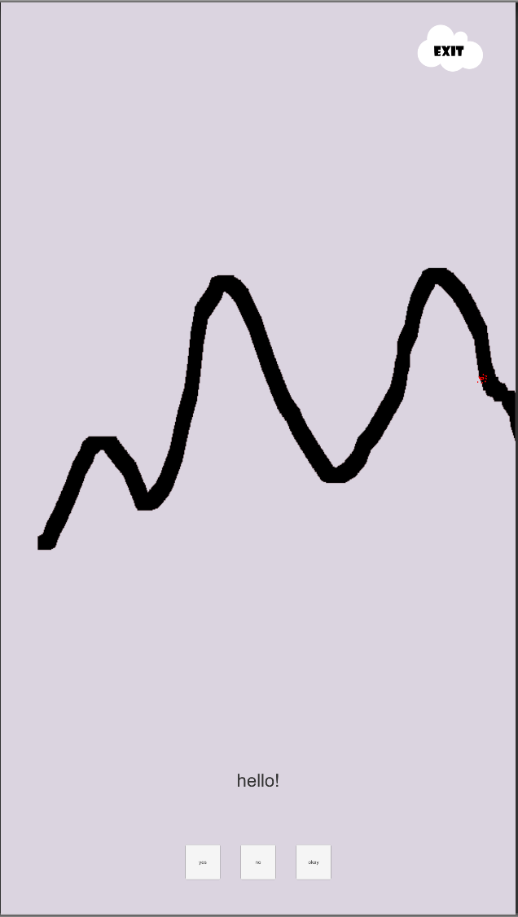

(click start button and you’ll see your game being displayed)

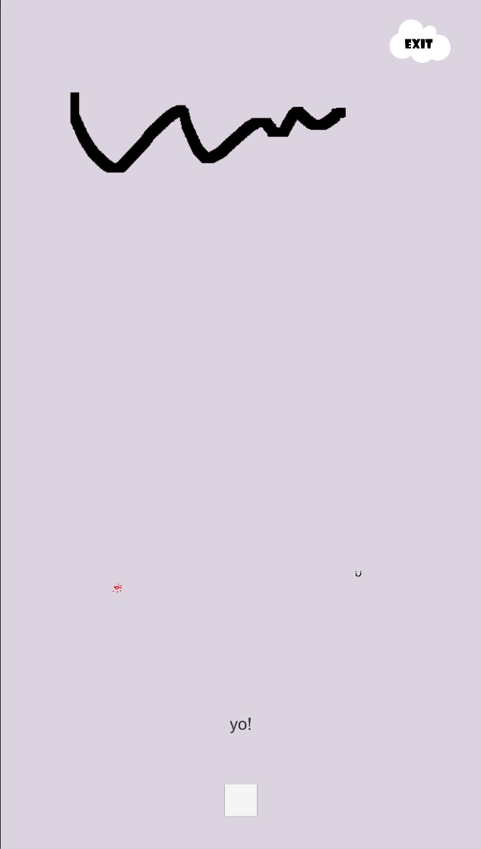

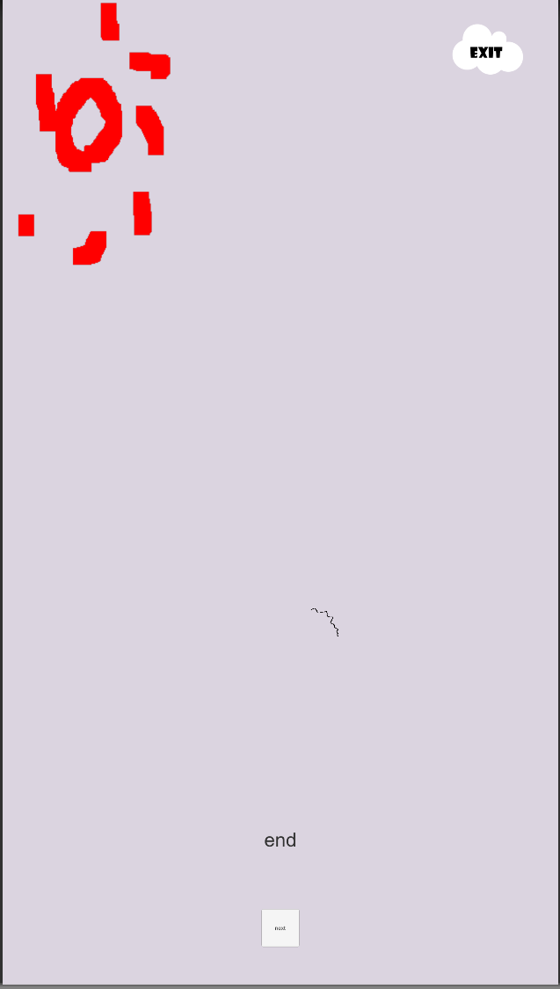

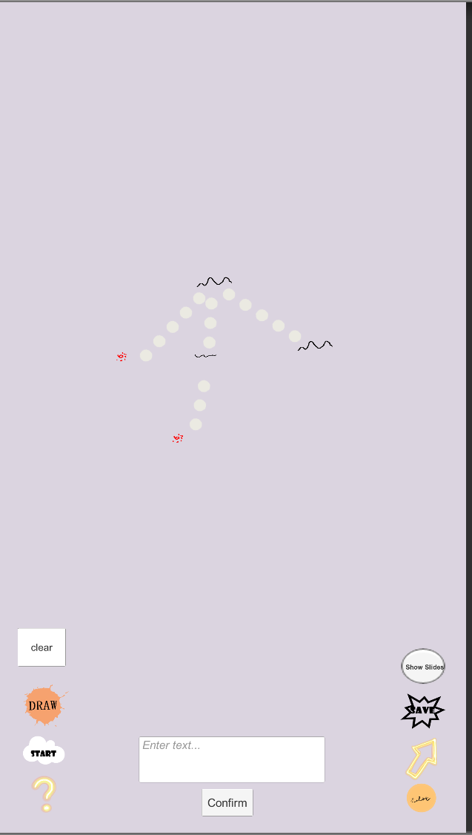



(click exit to go back to main page, then click save button, give it a name the you can upload your multi-ending story to the server)